Cody Stein

Finn Willard

Nov 15th, 2020

ECE 578 - Project 2

Internet Topology at the Autonomous Systems level

**AS Classification**

Three Autonomous Systems (AS) are studied in this report; Transit/Access, Content, and Enterprise. Transit/Access ASes provide connections from one AS to another, through itself. Content ASes are multihomed, meaning that they are connected to more than one AS, allowing for connections to remain in the event that one fails. Lastly, Enterprise ASes are usually stubs, connecting to only one other AS from the view of the public, but may be connected to other ASes internally. In this study, data was obtained from caida.org. Figure 1 represents the distribution of the three previously mentioned AS classifications in our data.

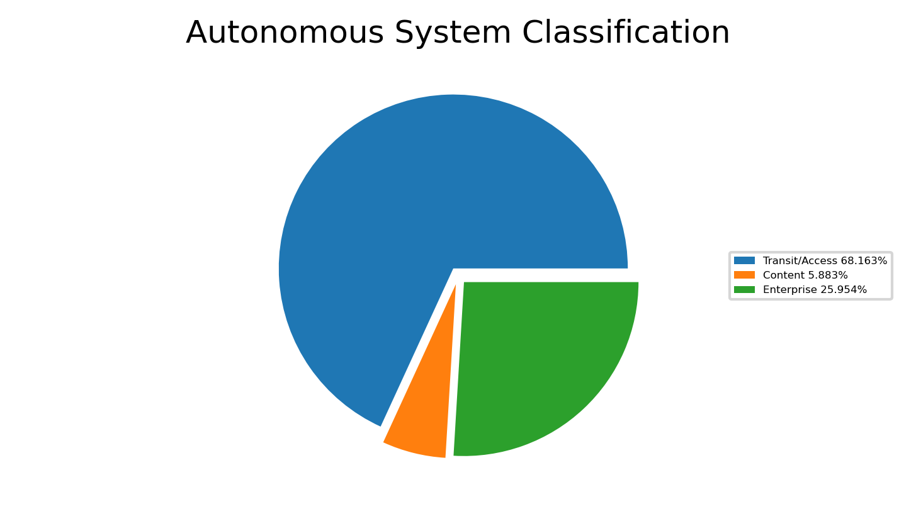

Figure 1

**Topology Inference Through AS links**

Another set of data was then used to explore the AS relationships by simulating the topology by utilizing AS links. This data set was once again provided by Caida.org. Once loaded, the data was distributed into 6 bins representing ranges of AS node degree as shown in figure 2.

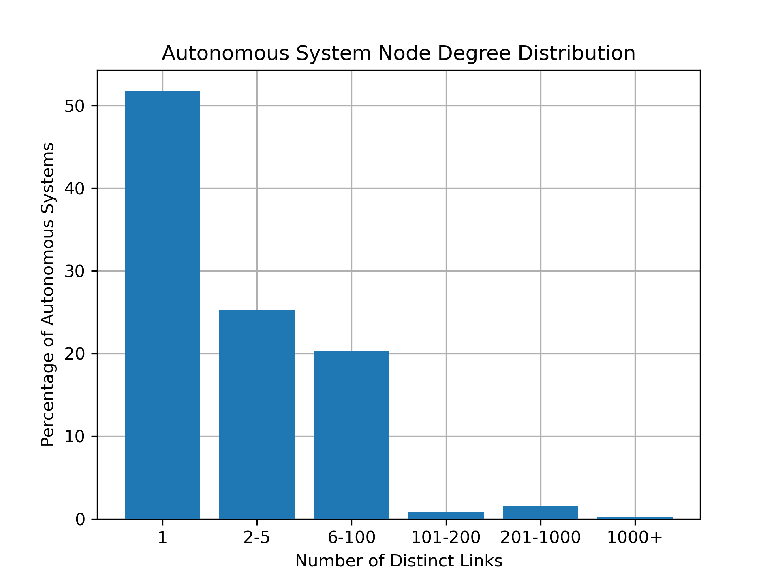

Figure 2

Looking at graph 2, one can see that the distribution of node degree is heavily weighted towards the lower end of the spectrum with nearly 95% of all AS nodes having a degree of 100 or below. This aligns with graph 1 where a significant portion of classifications were Transit/Access which by definition have a low degree count.

**IP Space Analysis**

A third set of data was analyzed to explore the IP space assigned to individual AS nodes. Each AS has a number of IP address prefixes assigned with various prefix lengths. By calculating the total number of IP addresses for each node and prefix length combination, we can see the distribution of the IP addresses for the various AS nodes. A histogram presenting this data can be seen below.

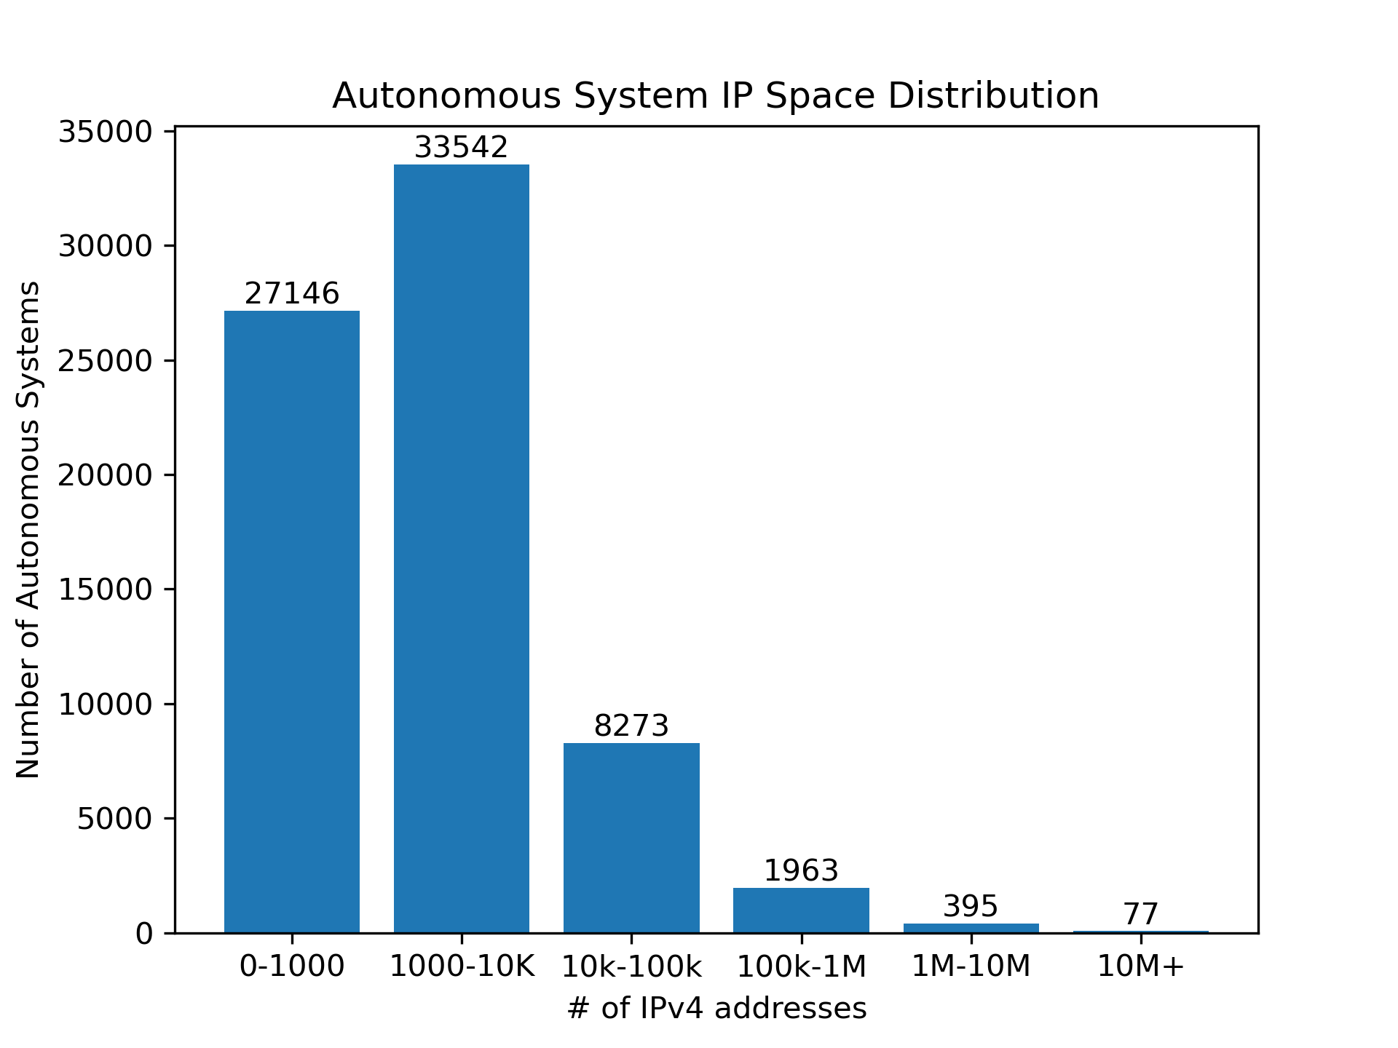

Figure 3

Examining this histogram we see that, like the degree distribution, the IP space distribution is heavily skewed towards smaller numbers of IP addresses, with only 3.4% of AS nodes having more than 100,000 IP addresses assigned. This is consistent with what was found in figure 1 and figure 2, with the majority of AS nodes being of the Transit/Access type and requiring fewer IP addresses.

**Further Analysis of AS Classification**

When looking at data from the first three datasets, there are some small differences that can raise questions. To look further into this, a deeper dive was conducted into the classifications. Classifications were further split up into two categories each as follows:

* Transit/Access with at least one customer, Transit/Access other
* Content with no customers and more than one peer, Content other
* Enterprise with no customers or peers, Enterprise other

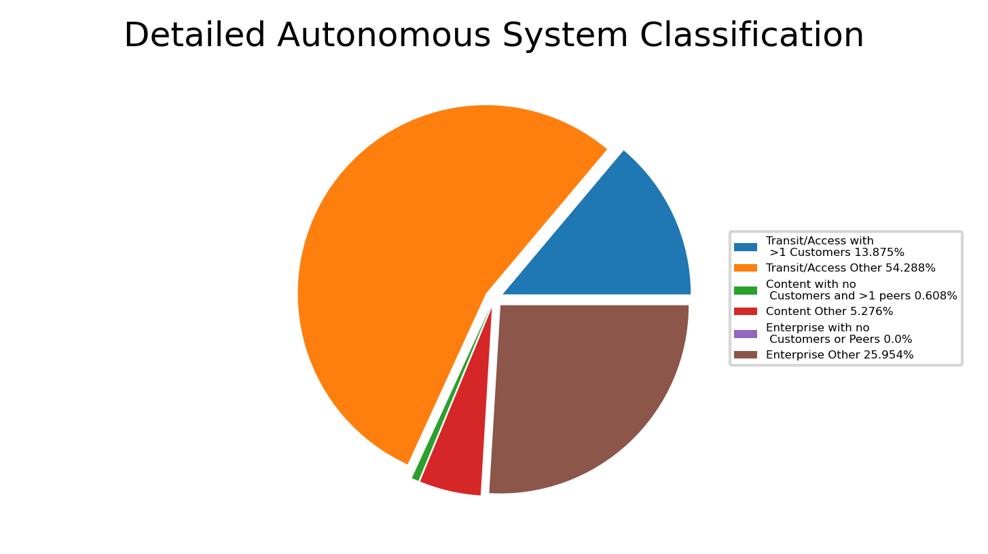

Figure 4

When looking at graph 4, we can see that Transit/Access AS nodes make up a majority of the total once again, as it should. Interestingly, Enterprise with no customers or peers doesn’t have a single entry. Upon further reflection, this makes sense as no one is connected to it, it won’t be detected.

**Inference of Tier 1 ASes**

The tier 1 ASes are computed by the following heuristic:

* Rank all the ASes according to their degree and place them in the set R = {AS1, AS2, AS3, … } where the degree(ASi) > degree(ASi+1)
* Initialize the clique S = {AS1}
* If AS2 is connected to AS1 add it to S.
* If AS3 is connected to AS2 and AS1 add it to S.
* Terminate when we find the first AS that is not connected to all the other ASes.

Since we were unable to find 10 ASes in a clique with the above heuristic, we began to ignore the ASes that were not connected in an attempt to find 10 ASes in a clique. Whenever an AS was found that was not connected to all the other ASes, it was ignored instead of terminating, and we continued down the list until we found 10 ASes or exhausted the top 50 ASes in R. Ultimately we were only able to find 6 ASes that were connected to every other AS in the top 50.

These ASes are shown in table 1, ordered by degree.

|  |  |  |  |
| --- | --- | --- | --- |
| **Rank** | **AS ID** | **Degree** | **Name** |
| 1 | 6939 | 8709 | Hurricane Electric LLC |
| 2 | 24482 | 4454 | SG.GS |
| 3 | 51185 | 4407 | Onecom Global Communications LTD |
| 4 | 61568 | 3967 | ALOO TELECOM - FSF TECNOLOGIA SA |
| 5 | 199524 | 3441 | G-Core Labs S.A. |
| 6 | 267613 | 3211 | ELETRONET S.A. |

Table 1

We can see from this data that Hurricane Electric LLC is the highest ranked AS due to it having the highest degree.